
TRIBHUVAN UNIVERSITY
Department of Humanities and Social Science

Project Report On: “Kam Paunu Hos – A Freelance Site”

Content-Based Job Recommendation Algorithm

Submitted To
Department of Information and Technology
Kathmandu Siksha Multiple Campus

In partial fulfillment of the requirements of 6th Semester for the
Bachelor’s Degree in Computer Application
Submitted By:
Awiskar Acharya
Dipendra Khadka

Under Supervision of:
Mr. Yuba Raj Devkota
Award Title: Bachelor in Computer Applications
Declaration Sheet
(Presented in partial fulfillment of the assessment requirements for the above award)
This work or any part thereof has not previously been presented in any form to the University or to any other institutional body whether for assessment or for other purposes. We confirm that the intellectual content of the work is the result of our own efforts and of no other person.
It is acknowledged that the author of any project work shall own the copyright. However, by submitting such copyright work for assessment, the author grants the University a perpetual royalty-free license to do all or any of those things referred to in section 16(I) of the Copyright Designs and Patents Act 1988. (viz. to copy work; to issue copies to the public; to perform or show or play the work in public; to broadcast the work or to make an adaptation of the work).

Declared By:

Awiskar Acharya and Dipendra Khadka
Date: Febuary 12 2026

Tribhuvan University

Kathmandu Shiksha Campus
Satungal, Kathmandu

Supervisor Recommendation

I hereby recommend that this project, prepared under my supervision entitled “Kam Paunu Hos – A Freelance Site”, a web-based freelance marketplace platform that connects clients and freelancers in Nepal through job posting, bidding, real-time communication, and NPR-based payment tracking, and also includes a Content-Based Job Recommendation Algorithm for intelligent job matching based on skill, category, and keyword similarity, in partial fulfillment of the requirements for the degree of Bachelor in Computer Application (BCA) is processed for the evaluation.
.....................................
[Supervisor Name]
Yuba Raj Devkota
Supervisor
Kathmandu Siksha Campus
Date: ___________

TRIBHUVAN UNIVERSITY
Department of Humanities and Social Science

Kathmandu Shiksha Campus

Certificate of Approval
This is to certify that the project report entitled “Kam Paunu Hos – A Freelance Site” is a bonafide report of the work carried out by Mr. Awiskar Acharya and Mr. Dipendra Khadka under the guidance and supervision of the undersigned for the degree of Bachelor in Computer Application (BCA) at Kathmandu Siksha Campus, Tribhuvan University. This project is submitted in partial fulfillment of the requirements prescribed by Tribhuvan University for the award of the BCA degree. To the best of my knowledge and belief, this work is original, has been duly completed by the candidates, and is up to the standard in respect of content, presentation, and language for being referred to the examiner for evaluation.

......................................  Mr. Yuba Raj Devkota  Project Supervisor  Kathmandu Shiksha Campus | ......................................  Mr. Basanta Baral  Department Head(IT)  Kathmandu Shiksha Campus
......................................  External Examiner  Tribhuvan University | ......................................  Internal Examiner  Kathmandu Shiksha Campus

ACKNOWLEDGEMENT
It gives us immense pleasure to express our sincere gratitude with the happiest appreciation to all those respectable personalities who helped us to make our project work successive as well as productive.
Our sincere appreciation goes to our mentors, teachers, and guides, without whose unwavering support and assistance this project would not have come to fruition. We are deeply thankful for the continuous help and support provided by the college throughout the development of the project.
Special thanks are owed to Mr. Yuba Raj Devkota for his invaluable supervision and assistance. His guidance and support were crucial during challenging moments, and without him, this project would not have been possible. We are grateful for his consistent error corrections, valuable suggestions, and guidance that proved to be instrumental throughout the project development. Additionally, we extend our thanks to all the teachers who provided us with the opportunity to undertake this project. Their encouragement and support were integral to the project's growth and success.

ABSTRACT
“Kam Paunu Hos – A Freelance Site” is a web-based freelance marketplace platform developed to support the growing gig economy in Nepal. The system is designed to connect clients and freelancers in a secure, efficient, and user-friendly environment where clients can post jobs and freelancers can bid on projects based on their skills and interests. The platform provides core features such as user registration and login, role-based access (Client, Freelancer, and Admin), job posting with categories and budgets, proposal-based bidding, and real-time communication through an integrated messaging system. To enhance user experience and job discovery, the system implements a Hybrid Skill-Based Job Recommendation Algorithm (HSBJRA) that recommends suitable jobs to freelancers by analyzing skill matching, category relevance, and keyword similarity. Additionally, the platform supports NPR-based payment tracking through eSewa integration, making the system more practical and locally applicable compared to international freelancing platforms. Security measures such as password hashing, CSRF protection, and controlled access are included to ensure safe user interactions and data protection. The system is developed using HTML, CSS, JavaScript, PHP, and MySQL, ensuring a responsive interface, reliable backend processing, and structured database management. This project contributes to Nepal’s digital economy by providing a localized freelancing solution that encourages employment opportunities, skill development, and economic inclusion for Nepali users.
Keywords: Freelance Marketplace, Job Posting, Bidding System, Real-Time Chat, eSewa Payment, Hybrid Recommendation Algorithm, PHP, MySQL, Nepal Gig Economy

Table of Contents
Certificate of Declaration ii
Supervisor Recommendation .Error! Bookmark not defined.iii
Certificate of Approval iv
Acknowledgement v
Abstract Error! Bookmark not defined.vi
List of Abbreviations Error! Bookmark not defined.ix
List of Figures ix
List of Tables x
Chapter 1: Introduction 1
1.1 Introduction Error! Bookmark not defined.2
1.2 Problem Statement Error! Bookmark not defined.2
1.3 Objectives Error! Bookmark not defined.2
1.4 Scope and Limitation Error! Bookmark not defined.3
1.4.1 Project Scope Error! Bookmark not defined.3
1.4.2 Limitation Error! Bookmark not defined.3
1.5 Development Methodology Error! Bookmark not defined.4
1.6 Report Organization Error! Bookmark not defined.6
Chapter 2: Background Study and Literature Review Error! Bookmark not defined.7
2.1 Background Study Error! Bookmark not defined.7
2.2 Literature Review Error! Bookmark not defined.8
Chapter 3: System Analysis Error! Bookmark not defined.9
3.1 System Analysis Error! Bookmark not defined.9
3.1.1 Requirement Analysis Error! Bookmark not defined.9
3.1.2 Feasibility Analysis Error! Bookmark not defined.12
3.1.3 Analysis .13
Chapter 4: System Design 20
4.1 Design 20
4.1.1 Database Design 20
4.1.2 Form Design Error! Bookmark not defined.22
4.1.3 Interface Design 23
4.2 Algorithm Details Error! Bookmark not defined.26
Chapter 4: Implementation and Testing Error! Bookmark not defined.30
5.1 Implementation Error! Bookmark not defined.30
4.1.1 Tools used Error! Bookmark not defined.30
4.1.2 Implementation Details of Algorithm: Error! Bookmark not defined.33
4.2 Testing Error! Bookmark not defined.35
4.2.1 Test Cases for Unit Testing Error! Bookmark not defined.35
4.2.2 Test Cases for System Testing Error! Bookmark not defined.36
4.3 Result Analysis Error! Bookmark not defined.37
Chapter 5: Conclusion and Future Recommendations Error! Bookmark not defined.45
5.1 Conclusion Error! Bookmark not defined.45
5.2 Future Recommendation Error! Bookmark not defined.45
References Error! Bookmark not defined.47
Appendix Error! Bookmark not defined.57

List of Abbreviations
Abbreviation | Meaning
AJAX | Asynchronous JavaScript and XML
API | Application Programming Interface
BCA | Bachelor in Computer Application
CRUD | Create, Read, Update, Delete
CSRF | Cross-Site Request Forgery
DFD | Data Flow Diagram
ERD | Entity-Relationship Diagram
HSBJRA | Hybrid Skill-Based Job Recommendation Algorithm
HTML | Hypertext Markup Language
JS | JavaScript
JQUERY | JavaScript Query
JSON | JavaScript Object Notatin
MySQL | My Structured Query Language
NPR | Nepalese Rupees
PHP | Hypertext Preprocessor
SRS | Software Requirement Specification
UI | User Interface
UX | User Experience

List of Figures
Figure 1. 1 Waterfall Model................................................................................................. 5
Figure 3. 1 Use Case ......................................................................................................... 10
Figure 3. 2 ER-Diagram ..................................................................................................... 14
Figure 3. 3 DFD-0 Diagram ............................................................................................... 16
Figure 3. 4 DFD-1 Diagram ............................................................................................... 18
Figure 3. 5 Architectural Diagram ................................................................................... 39
Figure 3. 6 Schema Diagram ............................................................................................ 38
Figure 3. 7 Cascade Diagram.............................................................................................. 40
Figure 4. 1 Database Design .............................................................................................. 20
Figure 4. 2 Form Design .................................................................................................... 22
Figure 4. 3 Home Design ................................................................................................... 23
Figure 4. 4 Login Design ................................................................................................... 23
Figure 4. 5 Sign-Up Design ............................................................................................... 24
Figure 4. 6 Reset Password ............................................................................................... 25

List of Tables
Table 3. 1 Schedule Plan .................................................................................................... 13
Table 5. 1 Test case For Registration................................................................................. 35
Table 5. 2 Test Case for User Signup ................................................................................ 35
Table 5. 3 Test for Feature Extraction ............................................................................... 37



Ref No:
Date:
SUBJECT: APPROVEL OF PROJECT PROPOSAL
The project entitled “Kam Paunu Hos – A Freelance Site” proposed by
Awiskar Acharya and Dipendra Khadka for the partial fulfillment of the requirement for Bachelor in Computer Application (BCA), sixth semester has been approved for further development.
Proposal Evaluation Committee
- ____________________________
- ____________________________
- ____________________________
4.____________________________

________________________
Shatrughan Prasad Gupta
Campus Chief

Chapter 1: Introduction

1.1 Introduction
In Nepal, the freelance economy is witnessing significant growth, driven by an increasing number of professionals specializing in IT, graphic design, digital marketing, and content creation who seek flexible, skill-based employment opportunities. Despite this surge, global platforms such as Up work and Fiverr often fail to meet the localized needs of Nepali users, imposing high service fees, lacking NPR (Nepalese Rupees) payment integration, and offering minimal support for the Nepali language and cultural context. To address these limitations, this project proposes the development of “Kam Paunu Hos – A Freelance Site”, a localized freelance marketplace platform designed exclusively for the Nepali market. The system serves as a bridge between freelancers and clients, providing a secure, efficient, and culturally relevant environment for job posting, bidding, project management, and payments. The platform has been developed using HTML, CSS, and JavaScript for an interactive and responsive front-end interface, PHP for server-side programming, and MySQL for robust and scalable database management. It incorporates role-based user access for clients, freelancers, and administrators, secure registration and login with password hashing and login attempt lockout, job posting with image upload and category selection, bidding with proposal submission and duplicate prevention, real-time job-linked messaging through AJAX polling, NPR-based payment processing via eSewa including transaction signature generation and automatic job awarding on successful payment, a hybrid content-based recommendation engine that matches freelancer skills with job titles, categories, and keywords using exact, category, and keyword overlap scoring, and database triggers that automatically delete related bids, messages, and payments when a job or user record is removed. This project directly aligns with the BCA 6th Semester curriculum, integrating core concepts such as web programming, database design, client-server communication, dynamic content rendering, session management, file handling, AJAX-based real-time features, and secure payment gateway integration. Furthermore, the system aims to contribute to Nepal’s digital economy by promoting local talent, facilitating financial inclusion through NPR-based transactions, and reducing dependency on foreign freelance platforms.

1.2 Problem Statement
In Nepal, freelancers and clients face significant challenges when trying to connect and complete projects. Currently, most Nepali freelancers rely on international platforms like Upwork and Fiverr, which involve high service fees, currency conversion issues, and limited support for local payments (NPR). Many local clients struggle to find verified, skilled freelancers who understand the Nepali context and language, resulting in delayed projects and higher costs.
Additionally, there is no centralized platform in Nepal that provides job posting, bidding, real-time communication, and secure payments all in one place. Young professionals and students lack opportunities to build portfolios, gain experience, and participate in the local gig economy.
This project aims to solve these problems by developing a localized freelance marketplace that connects Nepali freelancers and clients efficiently, offers secure NPR-based payments, and provides intelligent job recommendations, thereby promoting skill development and economic inclusion.

1.3 Objectives
The main objectives of this project are as follows:
- To implement a job posting system Hybrid Skill-Based Job Recommendation Algorithm (HSBJRA) for suggesting Jobs.
- To provide real-time messaging and chat functionality for communication between clients and freelancers.

1.4 Scope and Limitation

1.4.1 Project Scope
This project focuses on developing a localized freelance marketplace for Nepal, aimed at connecting clients and freelancers efficiently while providing secure payment and intelligent job recommendations. The scope of the project includes:
- Implementing a user registration and login system with role-based access for Clients, Freelancers, and Admin.
- Developing a job posting and bidding system that allows clients to post projects with categories, budgets, and descriptions, and freelancers to submit proposals.
- Integrating real-time chat and messaging for seamless communication between clients and freelancers.
- Implementing eSewa payment tracking to facilitate secure NPR-based transactions.
- Incorporating a Hybrid Skill-Based Job Recommendation Algorithm (HSBJRA) to suggest relevant jobs to freelancers based on skills, categories, and keywords.
- Ensuring data integrity and automatic deletion of related records when jobs or users are removed.
1.The system is web-based; there is no mobile application in this version.
2.Payments are limited to eSewa; other gateways can be added in the future.
3.Recommendation algorithm uses hybrid matching but does not include advanced AI learning.
4.Users must have internet access to use the platform.
5.Real-time chat relies on server polling, which may slightly delay messages under heavy load.

1.5 Development Methodology
The project follows the Waterfall development model, a structured and sequential approach suitable when requirements are well-defined and changes are expected to be minimal. Each phase is completed before moving to the next, ensuring a clear progression in development.
The Waterfall model is applied to this project as follows:
- Requirement Analysis:
In this phase, requirements for the freelance platform are defined, including user roles, job posting and bidding features, payment integration, chat functionality, and the job recommendation system.
- System Design:
Based on the requirements, the system architecture is designed, defining modules, database schema, user interfaces, algorithms (including HSBJRA), and workflows for the platform.
- Implementation (Coding) Phase:
The design specifications are translated into actual code using HTML, CSS, JavaScript, PHP, and MySQL, building all modules for user management, job posting, bidding, messaging, payment, and recommendations.
- Testing Phase:
Individual modules are tested through unit and integration testing to ensure they work correctly and interact as expected with other components.
- Validation (System Testing) Phase:
The complete system undergoes system testing to verify that all features function according to the requirements, ensuring reliability, usability, and security.
- Deployment Phase:
After successful testing, the system is deployed on a web server, making it accessible to end-users in Nepal.
- Maintenance Phase:
Ongoing support is provided to address bugs, implement enhancements, and update the system based on user feedback or evolving requirements in the freelance marketplace.

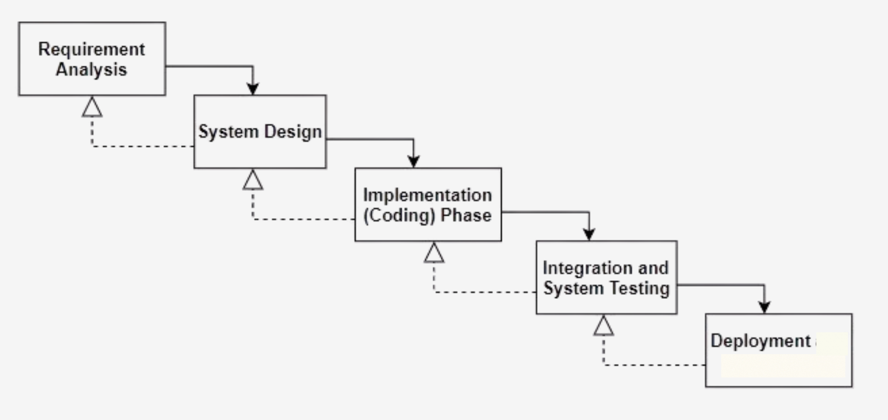

Figure 1. 1 Waterfall Model
Reason for Selection of Waterfall model as the development methodology
Since the project requirements are well-defined, stable and not expected to undergo significant changes. The Waterfall Model was selected for its ability to provide a controlled and predictable development process, catering to the specific characteristics and requirements of the counterfeit money detection project.

1.6 Report Organization
The report on “Kam Paunu Hos – A Freelance Site” is organized into six chapters as follows:
Chapter 1: Introduction
This chapter provides an overview of the project, outlining the objectives, problem statement, scope, limitations, and the chosen development methodology. It sets the foundation for understanding the need for a localized freelance marketplace in Nepal.
Chapter 2: Background Study and Literature Review
This chapter presents the study of fundamental concepts, theories, and existing systems related to freelancing platforms. It includes a literature review covering global and local freelance platforms, user preferences, and the challenges faced by Nepali freelancers and clients.
Chapter 3: System Analysis
This chapter focuses on the requirement analysis and feasibility study of the system. It also includes the Entity-Relationship Diagram (ERD), Data Flow Diagram (DFD), and functional/non-functional requirements to provide a clear understanding of the system’s structure.
Chapter 4: System Design
This chapter describes the overall system architecture, design of modules, workflows, and the Hybrid Skill-Based Job Recommendation Algorithm (HSBJRA) used for intelligent job matching.
Chapter 5: Implementation and Testing
This chapter details the tools and technologies used during development, including HTML, CSS, JavaScript, PHP, MySQL, and eSewa integration. It also covers unit testing, integration testing, and system testing to validate the functionality, performance, and reliability of the platform.
Chapter 6: Conclusion and Future Enhancements
This chapter summarizes the project’s outcomes, insights, and contributions to Nepal’s freelance economy. It also provides recommendations for future improvements, including mobile app development, additional payment gateways, and advanced AI-based job recommendations.

CHAPTER 2: Background Study and Literature Review

2.1 Background Study
The concept of freelancing has existed for many years, even before the widespread use of the internet. Traditionally, skilled individuals such as writers, artists, technicians, and consultants offered their services independently to clients within their local communities. However, freelancing became more organized and widely accessible with the development of the internet in the late 20th and early 21st centuries. The introduction of digital communication tools allowed individuals with the development of the platform like Up Work, Fiverr to work remotely and connect with clients from different parts of the world without physical meetings. In Nepal, freelancing started gaining popularity as internet access improved and platforms like Yeha Chaa has engaged more young people began learning digital skills such as graphic design, web development, content writing, and digital marketing. This shift created new opportunities for individuals to earn income independently and contribute to the growing digital economy.

2.2 Literature Review
The growth of digital freelancing has reshaped labor markets globally as well as locally in Nepal, creating both opportunities and challenges for workers and clients. A number of studies have examined various aspects of freelance marketplaces, from platform design and user experience to economic impact and labor dynamics.
Global research highlights how established platforms like Fiverr and Up work use algorithmic matching, reputation systems, and transactional workflows to support clients and freelancers, and how these features influence user engagement and platform success [1]. These platforms offer insights into designing robust job posting and bidding mechanisms and emphasize that efficient matching and feedback systems contribute significantly to platform sustainability.
In developing regions such as South Asia, studies show that the gig economy is rapidly growing due to increased internet access, youth unemployment, and the need for alternative income sources, but also faces structural challenges such as lack of legal protections, financial literacy, and cultural adaptation of technology [2]. In the Nepalese context, research on the rise of gig work reveals that while digital freelancing participation is increasing, workers still experience income instability, unclear work expectations, and limited access to localized payment systems [3]. These findings suggest that a localized freelance platform tailored to Nepal’s socio-economic context could address unique market needs.
Trust and perceived value are fundamental for freelancer retention on platforms. Studies indicate that transparent pricing, secure payments, dispute resolution, and clear communication channels significantly affect long-term user engagement [4]. This is particularly relevant for Nepali users, who often face challenges with international payment gateways and currency conversion losses.
User experience and skill development are also important factors in encouraging sustainable engagement. Research has shown that platforms that support freelancer skills, offer clear navigation, and foster professionalism are more likely to maintain active users and higher job completion rates [5]. Design research further argues that incorporating worker-centered features such as portfolio building, skill badges, and evaluation tools improves overall satisfaction and increases the perceived utility of the platform [6].
Labor economists have examined how gig economies influence labor norms, employment structures, and income distribution, finding that platform governance and fairness policies play a large role in user trust and economic outcomes [7]. Such insights highlight the importance of carefully designed role-based access and secure transaction tracking for platforms like Kam Paunu Hos.
Market research on freelance platforms identifies pricing transparency, effective recommendation features, and reliable feedback mechanisms as key attributes that sustain user engagement and economic growth [8]. Studies on collaborative behavior among freelancers’ further show that community-oriented tools, peer reviews, and social features enhance job acquisition and completion rates [9].
Books on the gig economy provide foundational theories regarding digital platforms and labor transformations, presenting frameworks that inform system design principles related to user empowerment, platform regulation, and equitable economic participation [10].
Local news outlets in Nepal have also reported on the increasing presence of freelance work among Nepali youth, indicating that many workers earn income from skills such as web development, design, writing, and digital marketing, yet face challenges with client trust, payment security, and lack of local platforms to facilitate smoother interactions [11]. Community forums and tech blogs reiterate this sentiment, showing how freelancers often seek Nepal-specific solutions that support NPR payments, Nepali language interfaces, and culturally relevant job categories [12].

Chapter 3: System Analysis and Design

3.1 System Analysis
The system analysis of the Kam Paunu Hos platform involves defining objectives, gathering requirements, selecting appropriate technologies, designing a secure payment workflow, implementing job posting and bidding mechanisms, and creating a user-friendly interface to connect clients and freelancers efficiently while ensuring smooth transactions and task completion.

3.1.1 Requirement Analysis
The requirement analysis for the Kam Paunu Hos platform encompasses both functional and non-functional aspects essential for the successful operation of a localized freelance marketplace in Nepal.
i. Functional Requirements:
- User registration and login for both clients and freelancers
- Profile management, including skills, portfolios, and ratings
- Job posting by clients with details such as budget, deadlines, and skill requirements
- Job bidding by freelancers with proposals and expected cost
- Real-time chat or messaging system for communication between clients and freelancers
- Payment tracking in NPR with secure gateways
- Review and rating system for completed projects
- Notification system for job updates, bid status, and payment confirmation
ii. Non-Functional Requirements:
- The platform must be accessible via web browsers on desktops and mobile devices
- User interface should be intuitive and easy to navigate
- Secure handling of personal and financial data
- Fast performance for loading pages, messages, and job listings
- Scalability to handle multiple users and concurrent transactions
- Backup and maintenance plan to ensure data integrity and platform availability

iii. Use Case Diagram:
The use case diagram will depict the interactions between the system and users (clients and freelancers), showing how users can register, post or bid on jobs, communicate, process payments, and provide feedback.
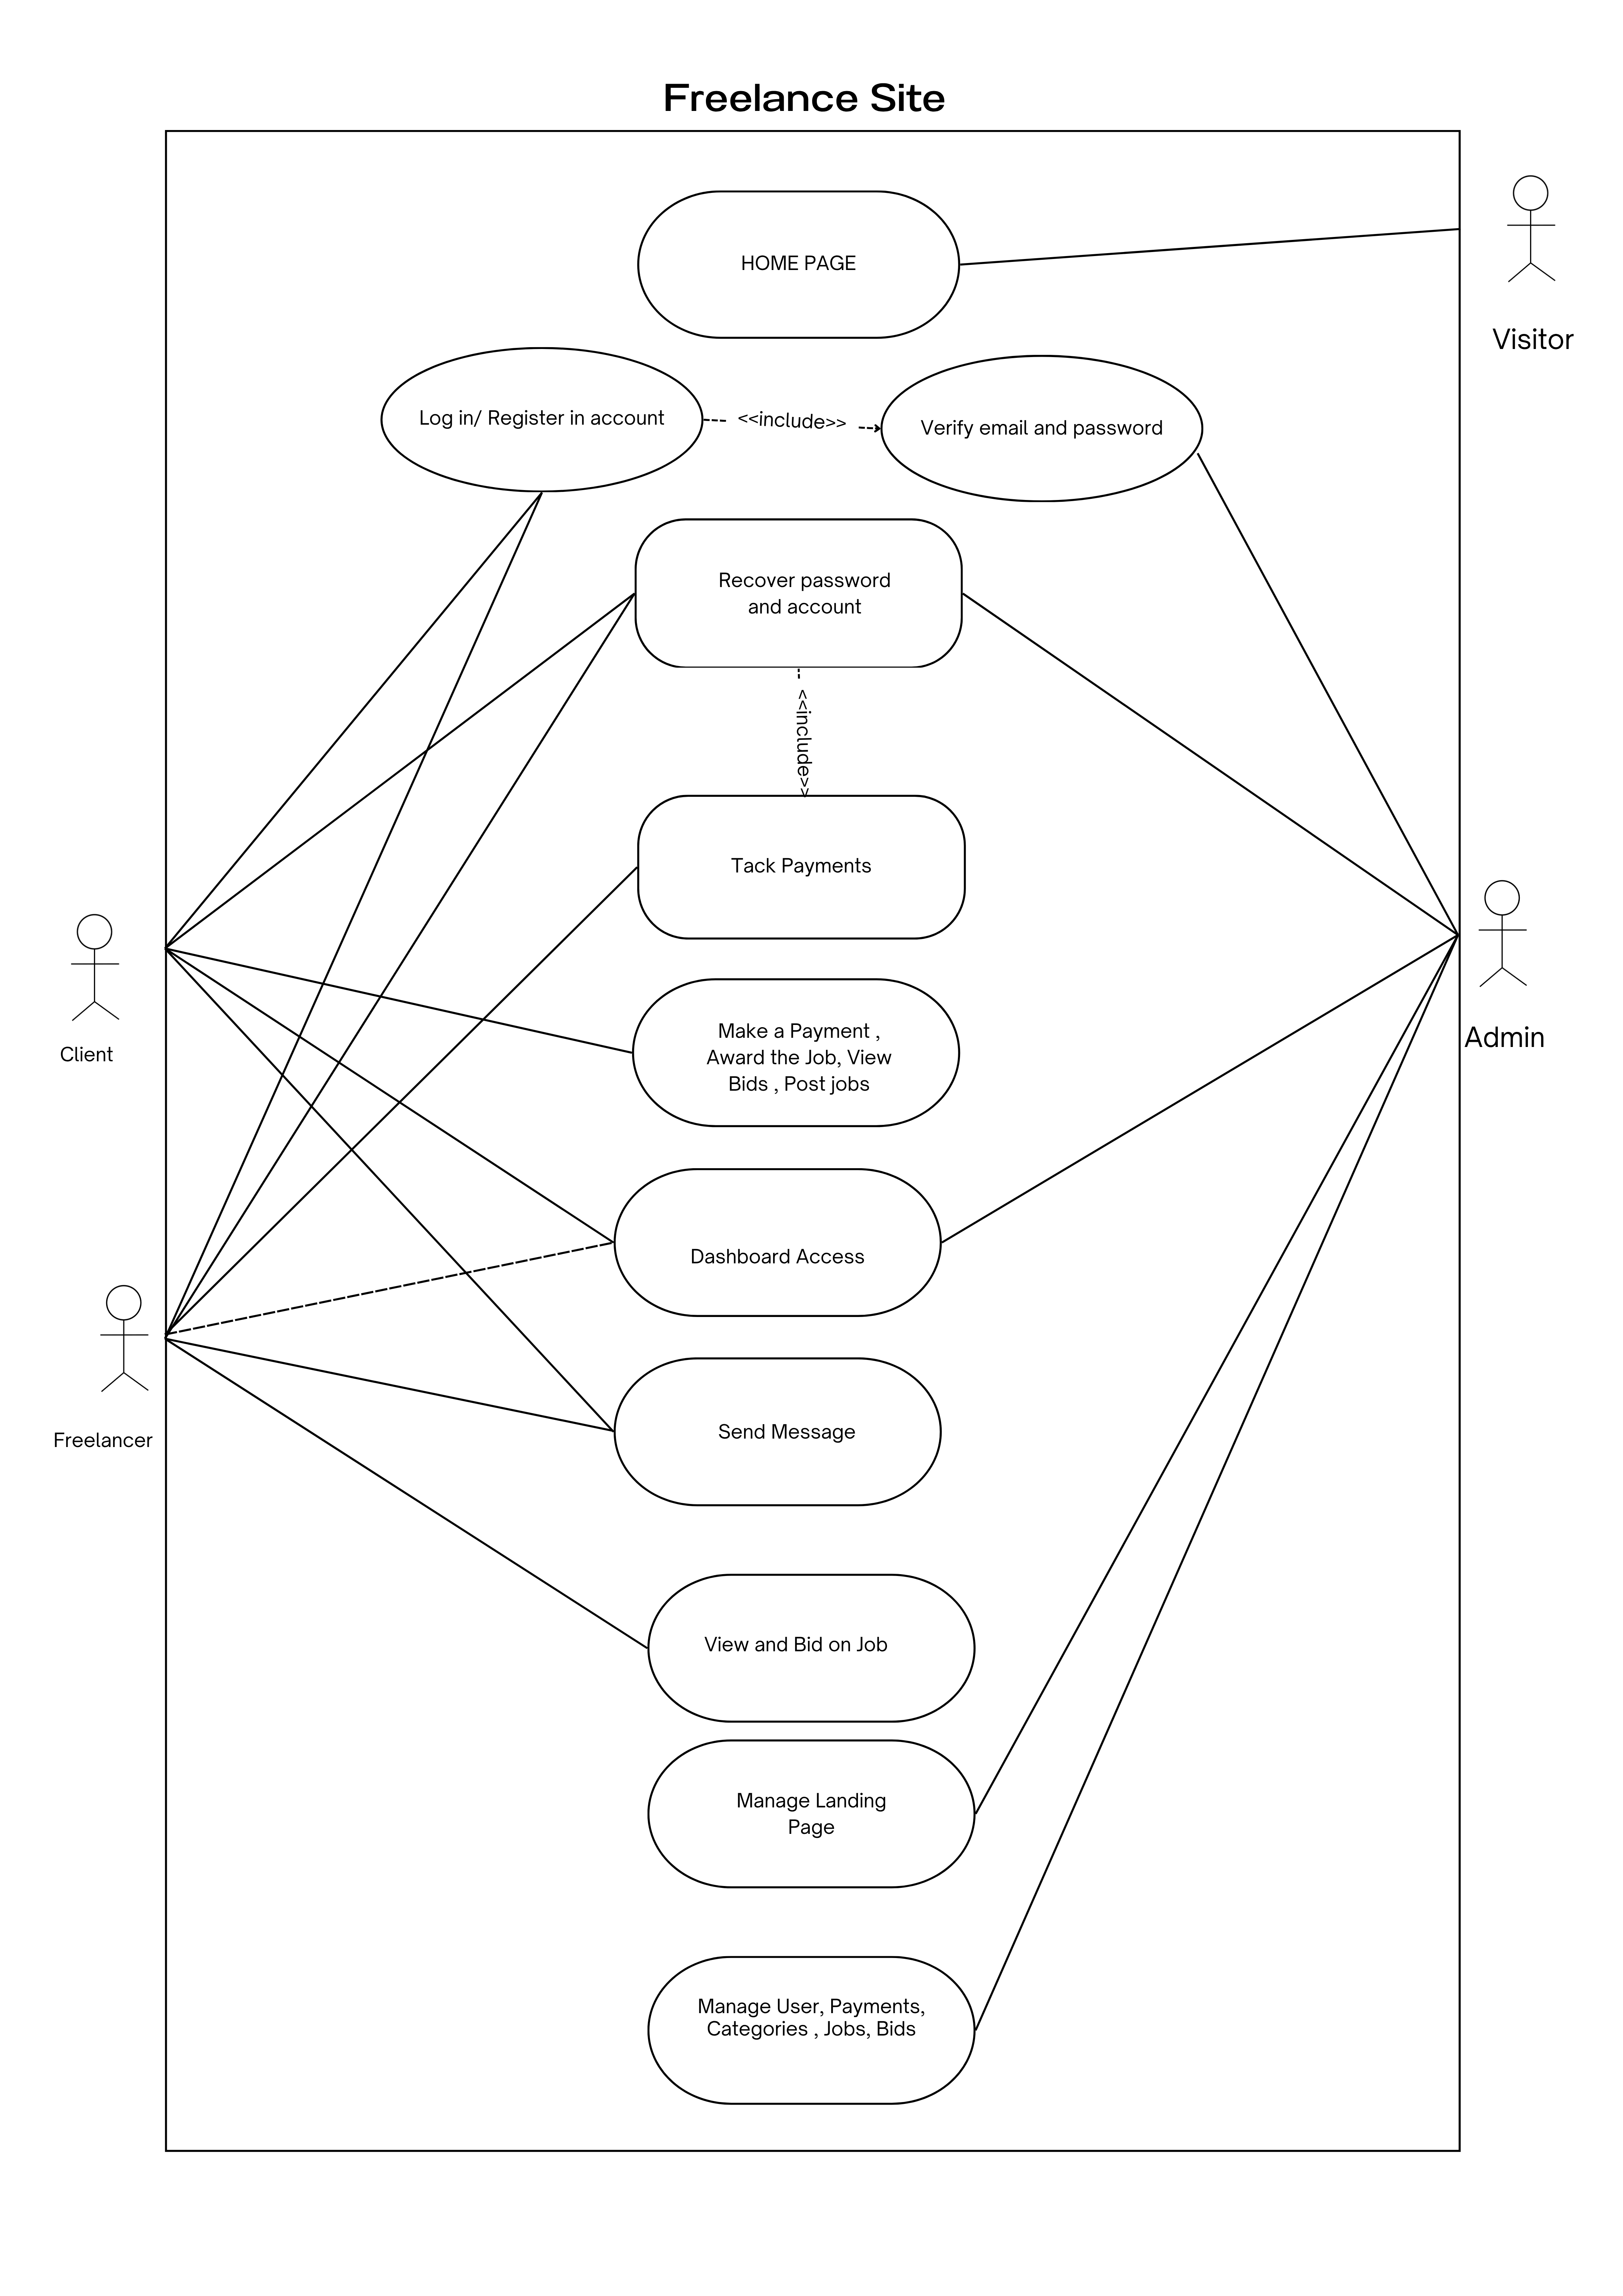
Figure 3.1 USE CASE DIAGRAM
Use Cases:
a. Login:
- Actor: User (Client/Freelancer)
- Description: Users log into the system using their username and password.
b. Registration:
- Actor: User
- Description: New users can register on the platform by providing necessary information such as name, email, skills, and password.
c. Job Posting:
- Actor: Client
- Description: Clients post jobs with details such as project description, budget, deadline, and required skills.
d. Bidding:
- Actor: Freelancer
- Description: Freelancers can submit proposals for posted jobs with price and expected timeline.
e. Communication:
- Actor: Client/Freelancer
- Description: Users communicate via the platform’s messaging system to discuss project requirements.
f. Payment Tracking:
- Actor: System
- Description: The system tracks payments in NPR and updates the status of completed transactions securely.
g. Review & Rating:
- Actor: Client/Freelancer
- Description: After project completion, users can rate and review each other to maintain trust and credibility.

ii. Non-Functional Requirements
Non-functional requirements ensure the platform is reliable, secure, and easy to use:
- Performance: Fast response for job postings, bids, messaging, and payment updates.
- Reliability: Consistent uptime and error-free operations.
- Usability: Intuitive interface with HTML, CSS, Bootstrap for easy navigation.
- Security: Data encryption, secure login, and safe handling of user payments.
- Scalability: Capable of handling a growing number of users, jobs, and transactions.
- Maintainability: Modular PHP backend and MySQL database design allow for easy updates and feature additions.

3.1.2 Feasibility Analysis

i. Technical Feasibility
The technical feasibility is high since all the technologies used are well-established, accessible, and compatible with most systems:
Hardware Requirements:
- Computer with minimum 4 GB RAM and multi-core processor
- Storage for user data, job history, and uploaded files
Software Requirements:
- Backend: PHP (server-side scripting)
- Database: MySQL (data storage and retrieval)
- Frontend: HTML, CSS, JavaScript, Bootstrap (responsive UI)
- Diagrams & UI Prototypes: Canva, Figma, Draw.io
- Web Browser: Chrome, Firefox, Safari
Optional: Any local or cloud server (like XAMPP, WAMP) for PHP development and testing.

ii. Operational Feasibility
Operational feasibility is moderate to high because the system depends on active user engagement, seamless posting and bidding processes, secure payments, and a reliable messaging platform. The system’s success depends on user adoption, intuitive navigation, and responsiveness for both clients and freelancers.

iii. Economic Feasibility
Economic feasibility is high since PHP, MySQL, HTML, CSS, and JavaScript are open-source, requiring minimal cost for software. The development mainly involves human resources and optional cloud hosting.

iv. Schedule Feasibility
The project was developed over a semester, with time allocated for system design, front-end development, back-end implementation, database integration, testing, and deployment. Adequate time was provided for prototyping UI with Canva/Figma and designing diagrams with Draw.io.

S. No. | Task Name | Duration | Start Date | End Date
1 | Planning | 6 Days | 22 Aug, 2025 | 28 Aug, 2025
2 | Analysis | 8 Days | 29 Aug, 2025 | 5 Sep, 2025
3 | Design | 12 Days | 6 Sep, 2025 | 17 Sep, 2025
4 | Coding | 30 Days | 18 Sep, 2025 | 17 Oct, 2025
5 | Testing | 10 Days | 18 Oct, 2025 | 27 Oct, 2025
6 | Implementation | 6 Days | 28 Oct, 2025 | 2 Nov, 2025
7 | Documentation | 90 Days | 3 Nov, 2025 | 28 Jan, 2026

3.1.3 Analysis
Data Modeling using ER-diagram.
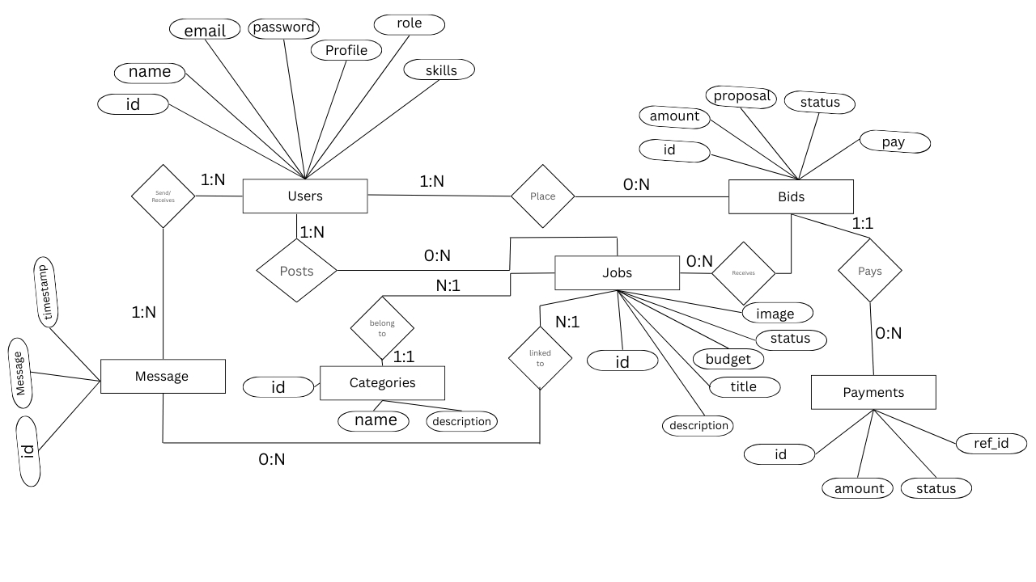

Figure 3.2 ER Diagram

ER (Entity-Relationship) Diagram for Kam Paunu Hos
In the ER diagram for Kam Paunu Hos, three key entities are represented: User, Job Post, and Bid/Project Status.

User Entity
The "User" entity represents all individuals registered on the platform, whether clients or freelancers. It has the following main attributes:
- user_id: Unique identifier for each user in the system, ensuring individuality and relational links with other entities.
- username: Chosen display name for the user during registration.
- email: Stores the user’s email address for communication and notifications.
- password: Stores the encrypted password for secure access to the account.
- user_type: Indicates whether the user is a freelancer or a client.

Job Post Entity
The "Job Post" entity represents the jobs created by clients on the platform. Key attributes include:
- job_id: Unique identifier for each job posted.
- client_id: References the user_id of the client who posted the job.
- title: The title or short description of the job.
- description: Detailed information about the project or job requirements.
- budget: The payment or budget allocated for the job, in NPR.
- posted_date_time: Timestamp of when the job was posted.
- status: Indicates the current state of the job (e.g., open, in progress, completed).

Bid / Project Status Entity
The "Bid/Project Status" entity captures bids made by freelancers and tracks the progress of jobs. Attributes include:
- bid_id: Unique identifier for each bid submitted by a freelancer.
- job_id: References the job being bid on.
- freelancer_id: References the user_id of the freelancer submitting the bid.
- bid_amount: The proposed price for completing the job.
- bid_date_time: Timestamp of when the bid was submitted.
- status: Tracks the bid/project status (e.g., pending, accepted, rejected, completed).
- completion_date_time: Timestamp when the project is marked completed.
- feedback_rating: Optional rating or feedback provided by the client after project completion.

This ER design ensures:
- Traceability: Each user, job, and bid can be tracked individually.
- Relationship clarity: Freelancers can bid on multiple jobs, clients can have multiple jobs, and each job can have multiple bids.
- Performance tracking: Feedback and status attributes allow performance monitoring.

Process Modeling using DFD
DFD-0 Level Diagram
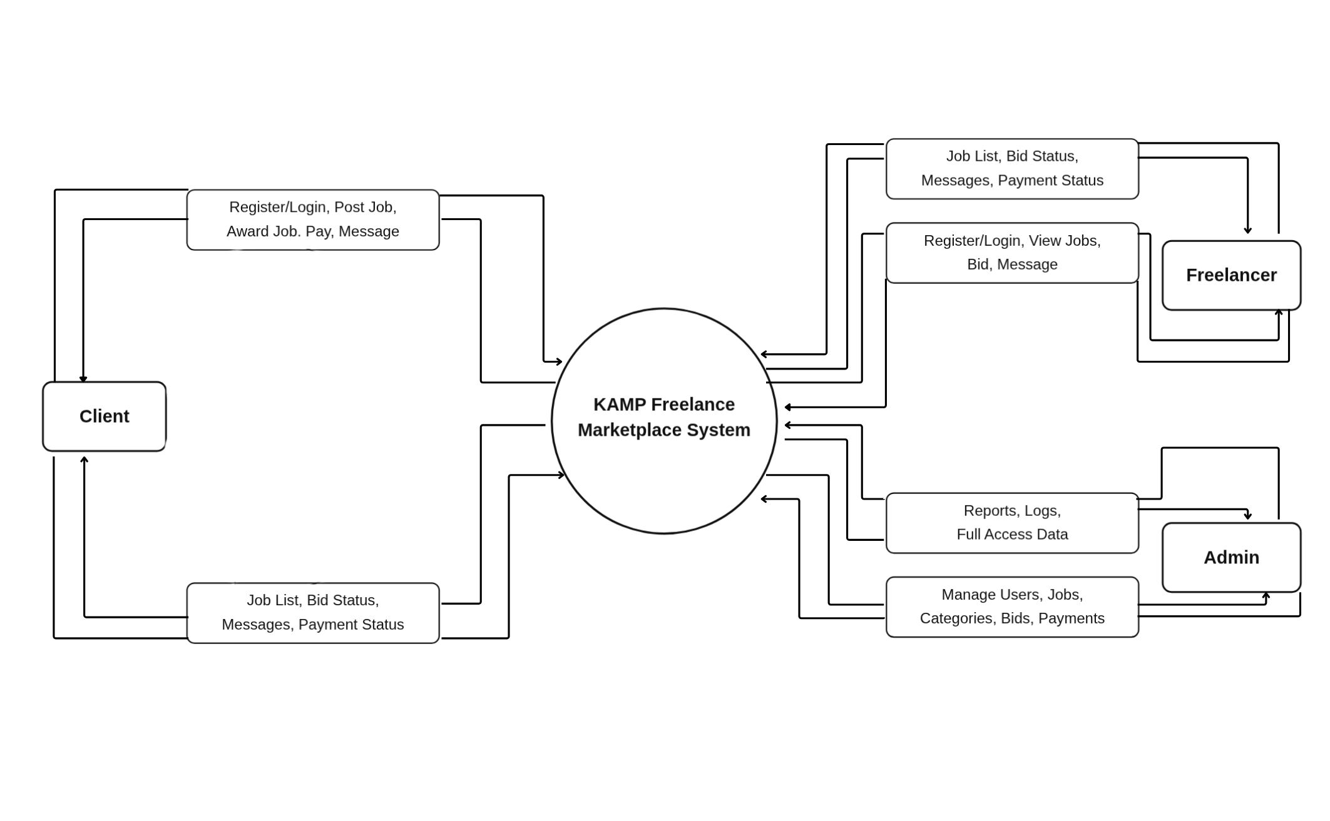

Figure 3.3 DFD 0 DIAGRAM

DFD-0 Level for Kam Paunu Hos
At the DFD-0 (context) level, the primary entities include the User (freelancer or client) and the Kam Paunu Hos system. Users interact with the system through key dataflows such as “login,” “register,” “post job,” and “submit bid”, which are directed toward the central Kam Paunu Hos process.
- Login / Register: Users authenticate themselves or create an account to access the platform. The system verifies credentials and provides access based on user type (client or freelancer).
- Post Job: Clients can submit new job postings with details like title, description, budget, and timeline. This data flows into the system for management and display.
- Submit Bid: Freelancers can submit bids on available jobs, including proposed budget and delivery time. These bids are processed and linked to the respective job.
The Kam Paunu Hos system processes these inputs and generates outputs like:
- Job List / Bid Status: Displays available jobs for freelancers and the status of submitted bids.
- Authentication Status: Confirms successful login or registration.
- Project Updates / Feedback: Provides updates on accepted jobs, completed projects, and ratings from clients.
This DFD-0 level diagram captures the essential interactions between users and the Kam Paunu Hos system, illustrating the core processes for user management, job posting, bidding, and result delivery.

DFD-1 level Diagram

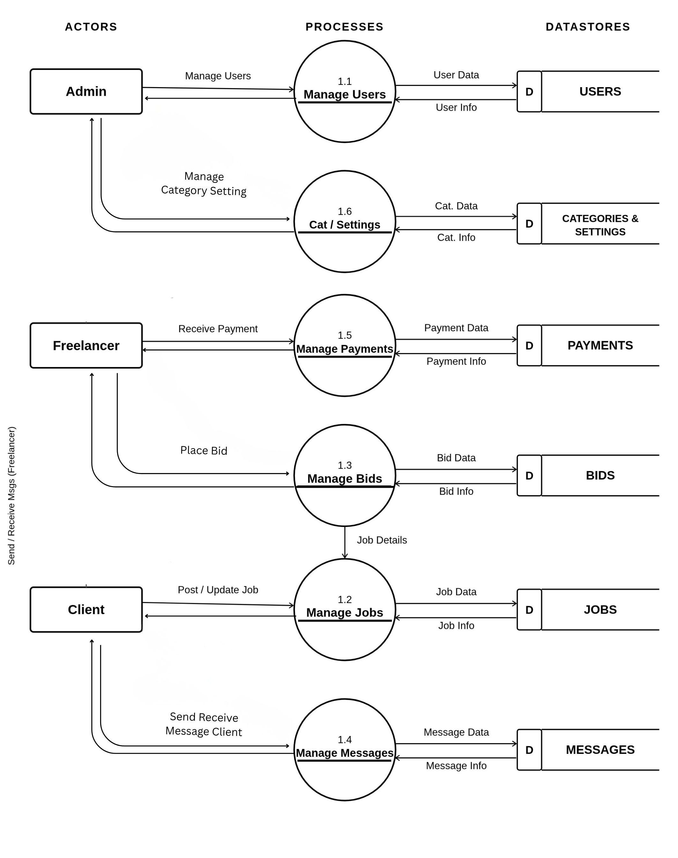
Figure 3.4 DFD 1 DIAGRAM

DFD-1 Diagram for Kam Paunu Hos
In the DFD-1 diagram, a single user entity interacts with multiple key processes within the Kam Paunu Hos system.
- User Authentication: Managed through the “User Login” process, ensuring that clients and freelancers access the platform securely.
- Registration / Account Creation: New users are handled by the “User Registration” process, which records user details and creates a unique account.
- Job Posting: Clients submit jobs through the “Post Job” process, providing details such as title, description, budget, and timeline.
- Bid Submission: Freelancers submit bids through the “Submit Bid” process, including their proposed budget and delivery time.
- Bid Evaluation and Job Assignment: The system evaluates bids in the “Bid Processing and Selection” process, matching the most suitable freelancer to a job.
- Feedback and Updates: After job completion, feedback and ratings are processed through the “Feedback & Project Update” process to update user reputation and project status.
The DFD-1 diagram also includes three main data stores to support system operations:
- User Table – Stores user credentials, profile information, and account details.
- Job Table – Contains job postings, details, deadlines, and client information.
- Bid Table – Records submitted bids, bid amounts, freelancer details, and project status.
This DFD-1 diagram provides a detailed overview of the subprocesses and data management flows in the Kam Paunu Hos platform, highlighting how user interactions, job postings, bids, and feedback are efficiently managed within the system.

3.2System Design

System Design is the process of defining the architecture, components, modules, interfaces, and data flow of a software system to meet specific requirements. It acts as a blueprint that guides developers in building scalable, efficient, and maintainable applications.

3.2 Design

3.2.1 Database Design

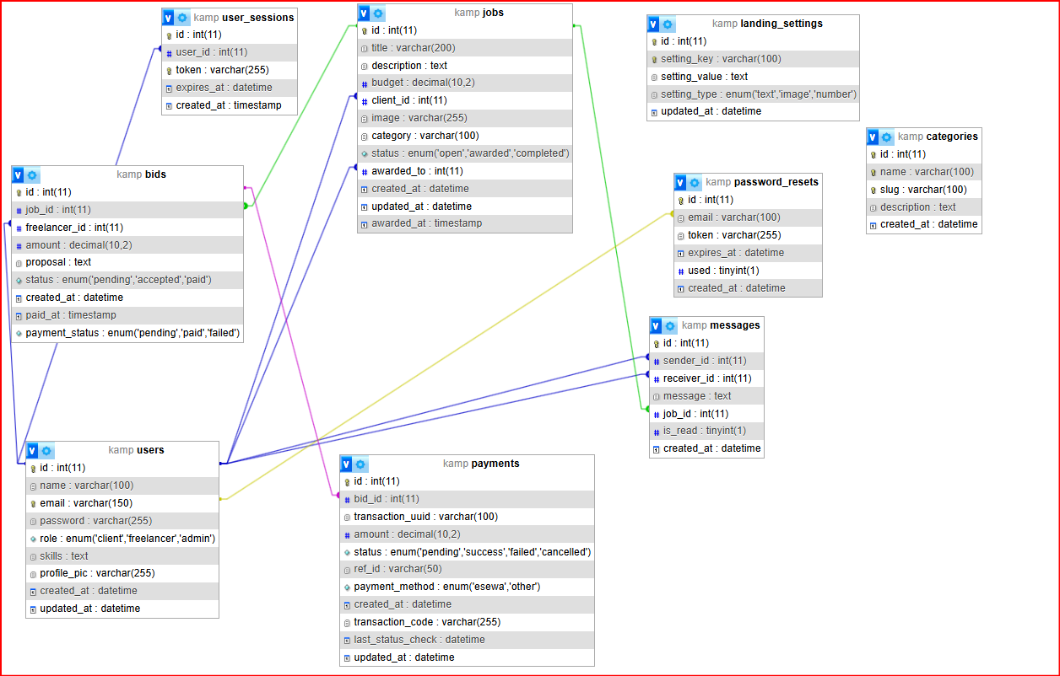

Relational Schema and Normalization for Kam Paunu Hos
The system’s Entity-Relationship (ER) diagram is transformed into a relational schema consisting of three primary tables: ‘user’, ‘job’, and ‘bid’.
- Each entity (user, job, bid) is represented as a table in the database.
- Attributes of each entity are translated into columns in the respective tables.
- Primary Key (PK): Each table has an id column serving as a primary key.
- Foreign Keys (FK):
  - The job table contains user_id as a foreign key referencing the client who posted the job.
  - The bid table contains job_id and user_id as foreign keys referencing the job and the freelancer submitting the bid.

Normalization
- First Normal Form (1NF)
  - Each table column contains atomic (indivisible) values.
  - No repeating groups or arrays exist; all data is stored in individual fields.
- Second Normal Form (2NF)
  - The tables are in 2NF since there are no composite primary keys.
  - Foreign keys (user_id in job and bid tables) do not create partial dependencies.
- Third Normal Form (3NF)
  - The tables are in 3NF since there are no transitive dependencies.
  - All non-primary attributes depend only on the primary key.

Form Design
Based on Kam Paunu Hos, forms were designed for both clients and freelancers:
- User Registration & Login Form
  - Allows users to create an account or log into the platform using PHP and MySQL.
  - Validates input using JavaScript and Bootstrap for responsive design.
- Job Posting Form
  - Allows clients to post new freelance jobs with details like title, description, budget, and deadline.
  - Uses PHP for form submission and stores data in the job table in MySQL.
- Bid Submission Form
  - Enables freelancers to submit bids for posted jobs, including proposed budget and estimated completion time.
  - Data is stored in the bid table and linked to both the user and the job via foreign keys.
- Contact Form
  - Allows users to send queries or messages to the platform’s support.
  - Form data is validated using JavaScript and sent via PHP backend for processing.
- Job Details & Dashboard Forms
  - Displays posted jobs, bids, and project status to users.
  - Integrated with Bootstrap, HTML, CSS, and JavaScript for a responsive and user-friendly interface.



2 Form Design

3.2.3 Interface Design
Interface design, often referred to as user interface (UI) design, focuses on creating visual elements and interactions that enable users to interact with a system or application. A well designed interface should be intuitive, visually appealing, and user-friendly.
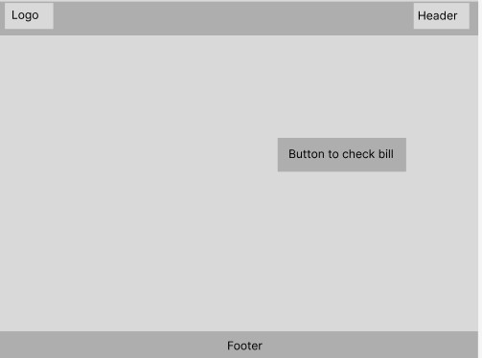

Figure 4. 3 Home Design

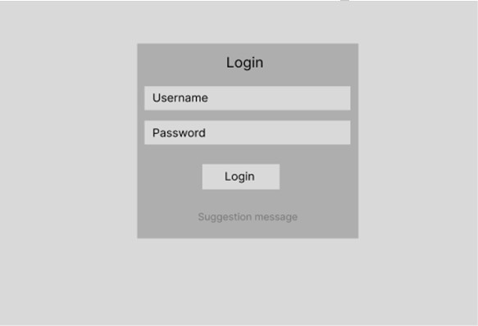

4 Login Design
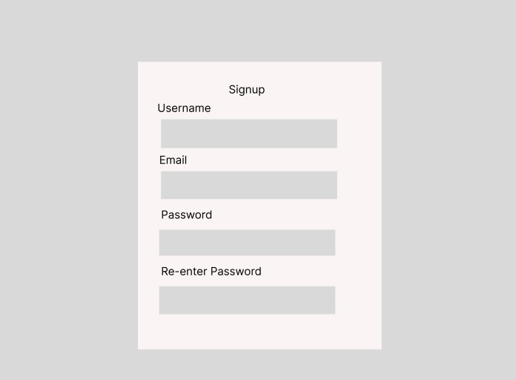

Figure 4. 5 Sign-Up Design

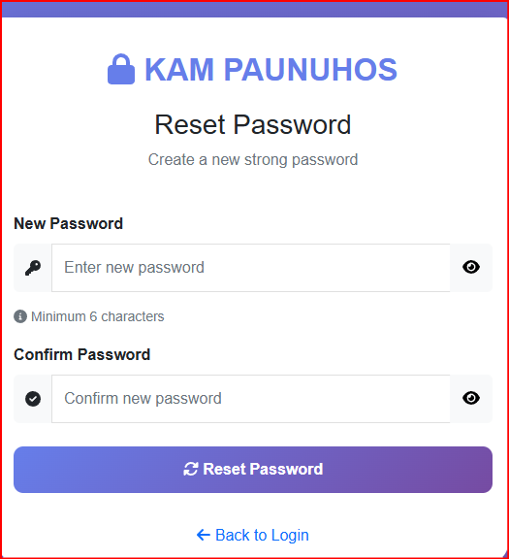
Reset password Form

Content-Based Job Recommendation Algorithm

Overview
This algorithm recommends jobs to freelancers based on a hybrid approach that combines exact skill matching, category matching, and keyword overlap. It is designed to be fast, reliable, and scalable, returning a maximum of 12 job recommendations per freelancer.
Core Idea:
- Exact skill matches are the strongest signal → highest weight
- Category matches are secondary
- Keyword overlaps provide smaller boosts
- Scores are capped at 100 points to prevent bias toward highly skilled freelancers

Steps / Algorithm Flow
- Load Freelancer Skills
$freelancer = $conn->query("SELECT skills FROM users WHERE id = $freelancer_id AND role='freelancer'");
- Fetch the skills of the freelancer from the users table.
- If no skills exist, fallback to returning recent 10 jobs.
- Preprocess Skills
$skills = array_map('trim', preg_split('/[\s,.;]+/', strtolower($freelancer['skills'])));
- Convert to lowercase
- Split skills using spaces, commas, periods, or semicolons
- Remove empty values
- Fetch Open Jobs
$jobs_query = $conn->query("SELECT id, title, description, budget, category FROM jobs WHERE status='open'");
- Retrieve all currently open jobs for scoring
- Score Each Job
$score = E(j) + C(j) + K(j)
4.1 Exact Skill Match (E(j))
- Check if each skill is present as a substring in the job title, description, or category
- Points: 30 per skill
foreach ($skills as $skill) {
if (stripos($job_text, $skill) !== false) $score += 30;
}
4.2 Category Match (C(j))
- Check if each skill matches the job category
- Points: 20 per skill
foreach ($skills as $skill) {
if (stripos($category_lower, $skill) !== false) $score += 20;
}
4.3 Keyword Overlap (K(j))
- Count the number of common unique words between job text and skills
- Points: 5 per common word
$common = array_intersect($job_words, $skills);
$score += count($common) * 5;
4.4 Normalize Score
- Maximum score is capped at 100 points
$score = min(100, $score);

Match Classification
Score Range | Match Level | Badge
≥ 60 | High | bg-success
30–59 | Medium | bg-warning
< 30 | Low | bg-secondary

Job Ranking
- Jobs are sorted by score in descending order
- Top 12 jobs are returned
usort($scored_jobs, fn($a, $b) => $b['score'] <=> $a['score']);
return array_slice($scored_jobs, 0, 12);

Mathematical Representation
- Input Skills
[S = { s_1, s_2, ..., s_n }]
- Job Text
[T_j = \text{title}_j + \text{description}_j + \text{category}_j]
- Exact Skill Match
[E(j) = 30 \sum_{i=1}^{n} I(s_i \in T_j)]
- Category Match
[C(j) = 20 \sum_{i=1}^{n} I(s_i \in \text{category}_j)]
- Keyword Overlap
[K(j) = 5 \cdot | W_j \cap S |]
Where ( W_j ) = unique words in job text
- Total Score
[\text{Score}(j) = \min(100, E(j) + C(j) + K(j))]
- Match Level
[\text{MatchLevel}(j) =
\begin{cases}
\text{High} & \text{if } \text{Score}(j) \ge 60 \
\text{Medium} & \text{if } 30 \le \text{Score}(j) < 60 \
\text{Low} & \text{if } \text{Score}(j) < 30
\end{cases}]

Special Cases
- No skills → Return latest 10 jobs
- No jobs matched → Return empty array

Complexity
- Time: (O(m \cdot n \cdot L))
  - (m) = number of jobs
  - (n) = number of freelancer skills
  - (L) = average length of job text
- Space: (O(m)) → store scored jobs

Chapter 4: Implementation and Testing

4.1 Implementation
Testing is the process of checking and confirming that a software application works correctly according to its requirements. Initially, the developer performs testing to ensure the system meets the specified goals. This chapter explains the implementation of the Kamp system using diagrams, pseudocode, and detailed explanations of its features. With proper planning and structure, the implementation phase becomes smooth and efficient.

4.1.1 Tools Used
Several tools and technologies were utilized to implement the Kamp system, as described below:

1. Programming Languages

i. HTML
HTML forms the structure of the Kamp system web pages:
- Includes metadata, links to CSS stylesheets, and JavaScript scripts.
- Defines navigation menus, headers, forms, and content sections.
- Enables user input, such as entering data or uploading files.
- JavaScript handles interactivity, such as buttons, redirection, or displaying results.

ii. CSS
CSS defines the visual presentation of Kamp:
- Styles are written in <style> tags or external files.
- Provides design for containers, buttons, forms, tables, and other elements.
- Ensures responsive layouts using media queries.
- Creates hover effects, colors, spacing, and fonts for better user experience.

iii. JavaScript
JavaScript adds functionality and interactivity:
- Handles button clicks, form validation, and dynamic content updates.
- Allows user input processing, calculations, or displaying results.
- Works with HTML elements and CSS styles for a smooth interface.

iv. Bootstrap
Bootstrap is used to enhance the design and responsiveness:
- Provides ready-to-use components such as buttons, forms, and tables.
- Ensures the website looks consistent across devices.

v. JSON
JSON is used to store and exchange structured data:
- Configurations, system settings, or user preferences.
- Lightweight and easy for JavaScript to parse and process.

2. Database: MY SQL
MY SQL is used to store Kamp system data, such as:
- User information (username, contact details).
- Records, entries, or logs related to Kamp operations.
- Query results or historical data for reference.
SQL queries allow insertion, retrieval, update, and deletion of records efficiently. MY SQL is lightweight and does not require a separate server, making it suitable for Kamp.

3. Development Framework: Flask (or similar)
Backend (PHP) is used, it handles:
- Routing for pages and forms (/home, /submit, /view).
- Processing data received from the user.
- Connecting to the database and returning results.
The backend allows the system to store, retrieve, and manage data seamlessly.

4. Diagram Tools
- Draw.io → Creating Entity-Relationship (ER) diagrams and Data Flow Diagrams (DFD) for system processes.
- Figma → Designing the user interface and visual layout of the system.

4.1.2 Implementation Details of Core Features
The Kamp system implements features such as data entry, processing, and display without AI or machine learning.

Example: Data Entry and Validation
- Input Form
<form id="entryForm">
<label>Enter Name:</label>
<input type="text" id="name" required>
<label>Enter Email:</label>
<input type="email" id="email" required>
<button type="submit">Submit</button>
</form>
- JavaScript Validation
document.getElementById('entryForm').addEventListener('submit', function(event) {
let name = document.getElementById('name').value;
let email = document.getElementById('email').value;

if(name === "" || email === "") {
alert("All fields are required!");
event.preventDefault();
} else {
alert("Data submitted successfully!");
}
});
- Database Storage
- User inputs are sent to the backend.
- Backend stores data into SQL:
INSERT INTO users (name, email) VALUES ('John Doe', 'john@example.com');
- Data Retrieval
- Records can be displayed dynamically in tables:
SELECT * FROM users;
- Data Display (HTML Table)
<table>
<tr><th>Name</th><th>Email</th></tr>
<!-- dynamically populate rows -->
</table>

4.1.3 System Features Implementation
- Responsive UI: Using Bootstrap + CSS for mobile-friendly interface.
- Input Validation: JavaScript ensures users enter correct data.
- Database Management: MY SQL handles storing, retrieving, and updating records.
- Data Display: User-friendly tables and panels to show results.
- Navigation and Routing: Users can move seamlessly between sections/pages.
- Visual Design: Figma and CSS ensure an intuitive and appealing interface.

4.1.2 Implementation Details of Core Algorithm: Job Recommendation for Kamp
The Kamp system implements a fast, reliable job recommendation algorithm for freelancers. This algorithm ensures users see jobs that match their skills, categories, and keywords without using AI.

Overview
The algorithm works as a hybrid matching system, combining:
- Exact skill matching (strongest match).
- Category matching (medium importance).
- Keyword overlap (small importance).
It returns 6–12 recommended jobs for each freelancer and never leaves the result empty.

Step 1: Get Freelancer Skills
- The system fetches the freelancer's skills from the users table in the database:
$freelancer = $conn->query("SELECT skills FROM users WHERE id = $freelancer_id AND role='freelancer'")->fetch_assoc();
- If the freelancer has no skills listed, the algorithm returns recent open jobs randomly:
return $conn->query("SELECT id, title, description, budget, category
FROM jobs WHERE status='open'
ORDER BY created_at DESC LIMIT 10")->fetch_all(MYSQLI_ASSOC);
- Otherwise, skills are cleaned, trimmed, and converted to lowercase for consistent matching

Step 2: Fetch All Open Jobs
- The algorithm retrieves all jobs with status='open' from the database.
- Each job includes: id, title, description, budget, category.
$jobs_query = $conn->query("SELECT id, title, description, budget, category
FROM jobs WHERE status='open' ORDER BY created_at DESC");

Step 3: Score Each Job
Each job is assigned a score based on matching rules:
- Exact Skill Match (strongest match)
  - If a freelancer skill appears in the job's title, description, or category, the score gets a 30-point boost.
- Category Match (medium boost)
  - If a skill matches the job category, the score gets a 20-point boost.
- Keyword Overlap (small boost)
  - The algorithm splits the job text into words and checks overlap with freelancer skills.
  - Each overlapping word adds 5 points.
- Normalize Score
  - The maximum score is capped at 100.
  - Based on score, a match level and badge color are assigned:
    - High (≥60) → green badge (bg-success)
    - Medium (≥30) → yellow badge (bg-warning)
    - Low (<30) → gray badge (bg-secondary)

Step 4: Sort by Score
- Jobs are sorted in descending order of score, so the best matches appear first.
usort($scored_jobs, function($a, $b) {
return $b['score'] <=> $a['score'];
});

Step 5: Return Top Jobs
- The algorithm returns the top 12 recommended jobs, or fewer if less are available.
return array_slice($scored_jobs, 0, 12);

Key Features
- Fast and Reliable – Works even if a freelancer has very few skills.
- Hybrid Matching – Combines exact skill, category, and keyword overlaps.
- Dynamic Scoring – Scores jobs between 0–100 with visual badges.
- Always Returns Jobs – Never gives an empty recommendation list.
- Flexible – Can be extended with new scoring rules or filters.

4.2 Testing
Testing ensures that all modules of the Kamp system function correctly and meet the design requirements. Each feature of the system has been tested thoroughly to confirm that it performs as expected.

4.2.1 Test Cases for Unit Testing
Unit testing involves testing individual modules to ensure proper data flow, correct processing, and accurate output. It verifies that temporary data is handled correctly during algorithm execution and that errors are managed properly

ID | Test Case Description | Test Data | Expected Result | Actual Result | Test Result
R_1 | User enters valid signup information | Email: awiskaracharya@gmail.com Password: 123456 Confirm Password: 123456 | Redirects to Login Page | Redirected to Login page | Pass
R_2 | User enters mismatched passwords | Email: awiskaracharya@gmail.com Password: 123456 Confirm Password: 23459 | Displays error message | “Password and Confirm password didn’t match.” | Fail

Table 5.2 Test Cases for User Login
ID | Test Case Description | Test Data | Expected Result | Actual Result | Test Result
L_1 | User enters valid login information | Email: awiskaracharya@gmail.com Password: 123456 | Redirects to Job Recommendation Page | Redirected to Job Recommendation Page | Pass
L_2 | User enters invalid login information | Email: awiskaracharya@gmail.com Password: 098765 | Displays error message | “Please enter a correct username and password.” | Pass
L_3 | User leaves login fields empty | Email: awiskaracharya@gmail.com Password: [empty] | Displays error message | “Please enter password.” | Fail

Table 5.3 Test Cases for Job Recommendation Algorithm

ID | Test Case Description | Test Data | Expected Result | Actual Result | Test Result
J_1 | Freelancer with skills matching jobs | Skills: PHP, HTML, CSS | Returns top jobs matching skills | Top 10–12 jobs displayed matching skills | Pass
J_2 | Freelancer with no skills entered | Skills: [empty] | Returns recent jobs randomly | Recent jobs displayed | Pass
J_3 | Freelancer skills partially match jobs | Skills: PHP, WordPress | Returns jobs with high/medium match scores | Jobs displayed with High/Medium/Low badges | Pass
J_4 | Jobs scoring correctly calculated | Skills: HTML, CSS, JavaScript | High matches ≥60, Medium ≥30, Low <30 | Correct match level assigned to each job | Pass
J_5 | Recommendation list never empty | Skills: [any] | At least 6 jobs returned | Always returns 6–12 jobs | Pass

Unit testing ensures all modules — registration, login, and job recommendation — work correctly.
Error messages and validations have been tested for user-friendly feedback.
The job recommendation algorithm has been tested to ensure accurate scoring, proper sorting, and non-empty results.

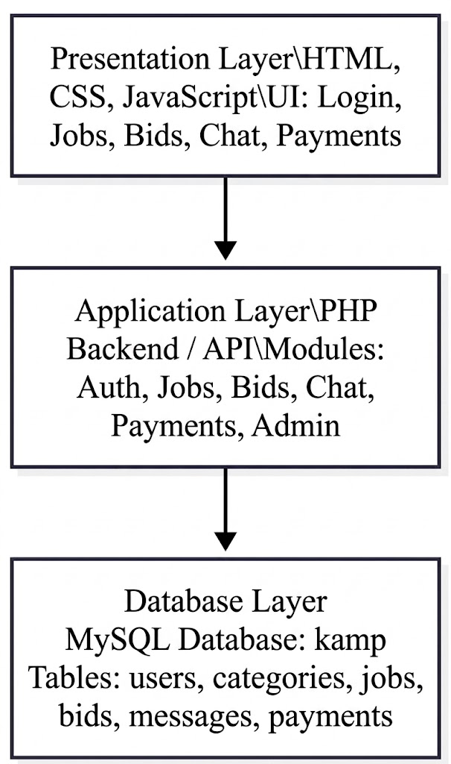

Figure: 3.5 Architectural Diagram
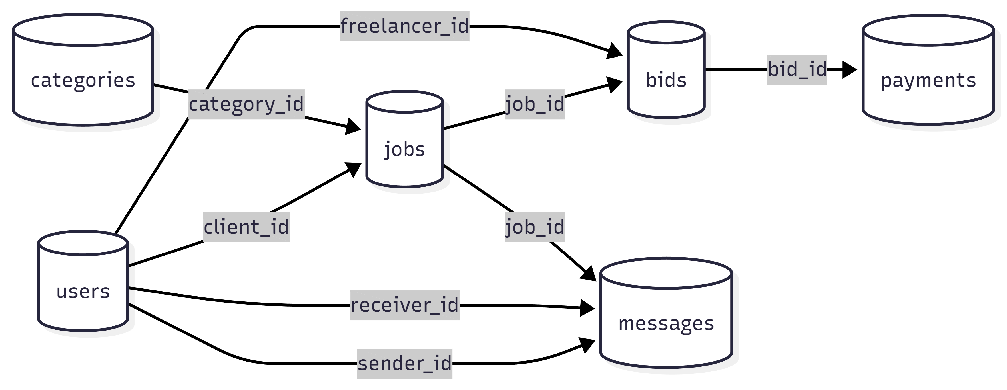

Figure: 3.6 Schema diagram

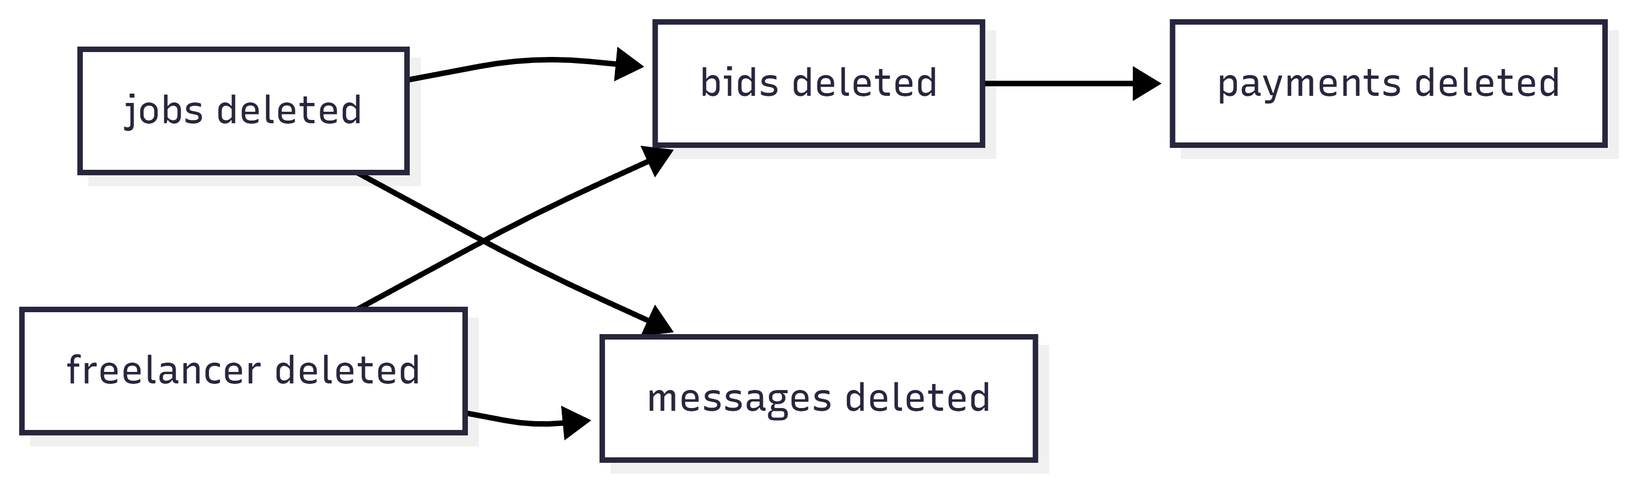

Figure 3.7 Cascade Diagram
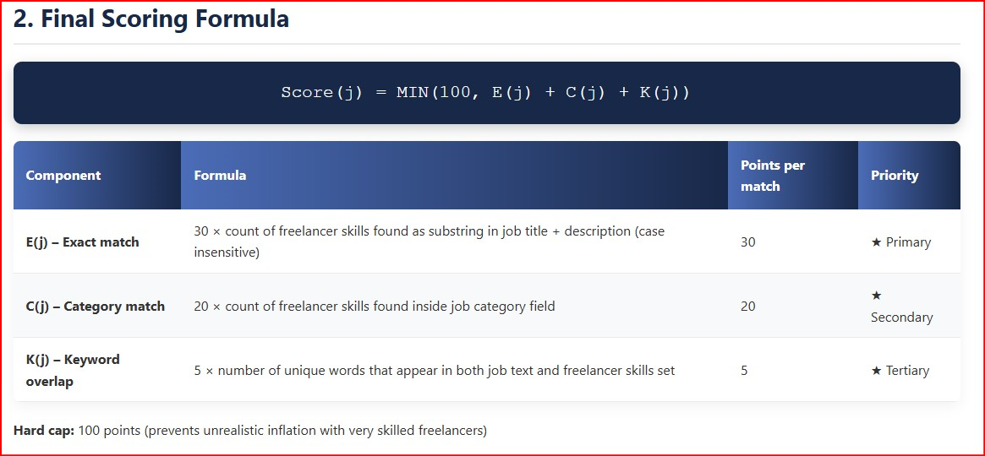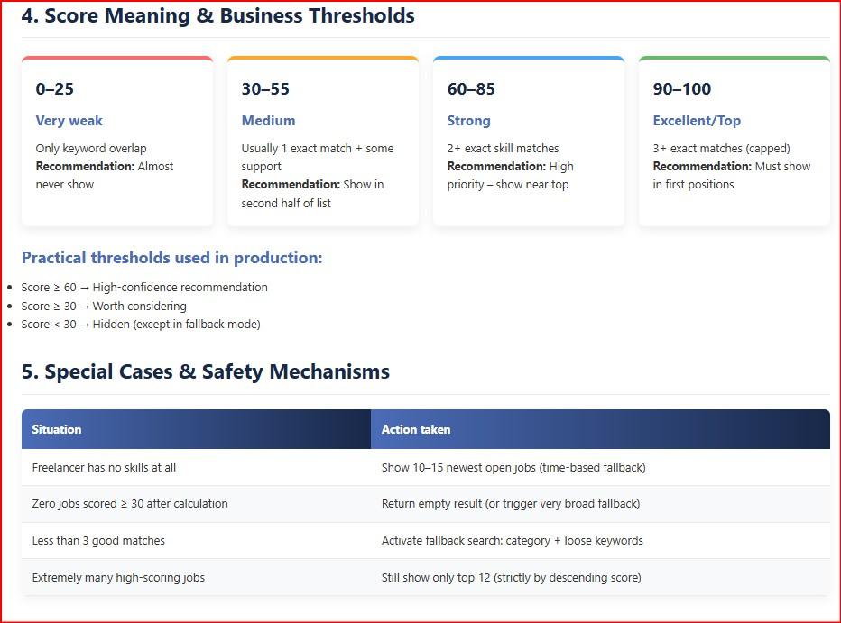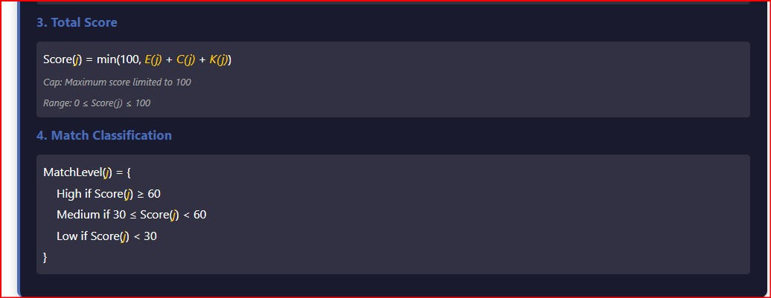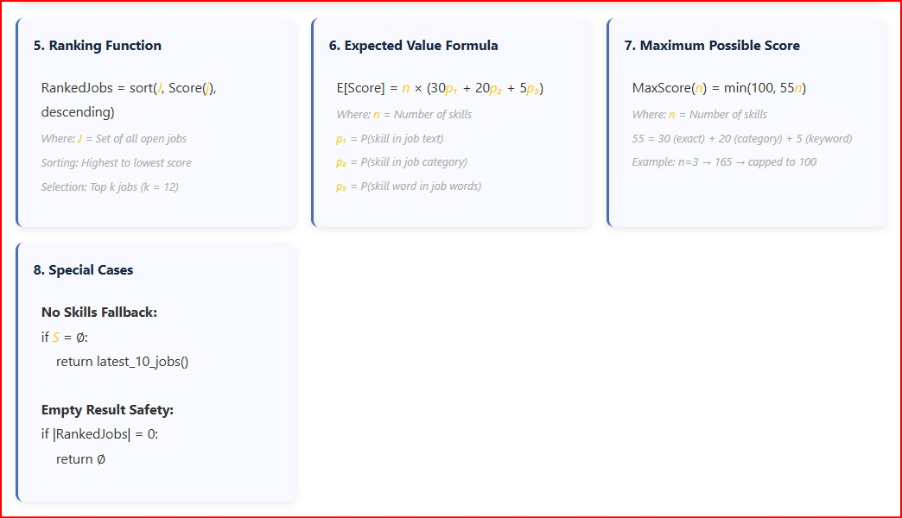

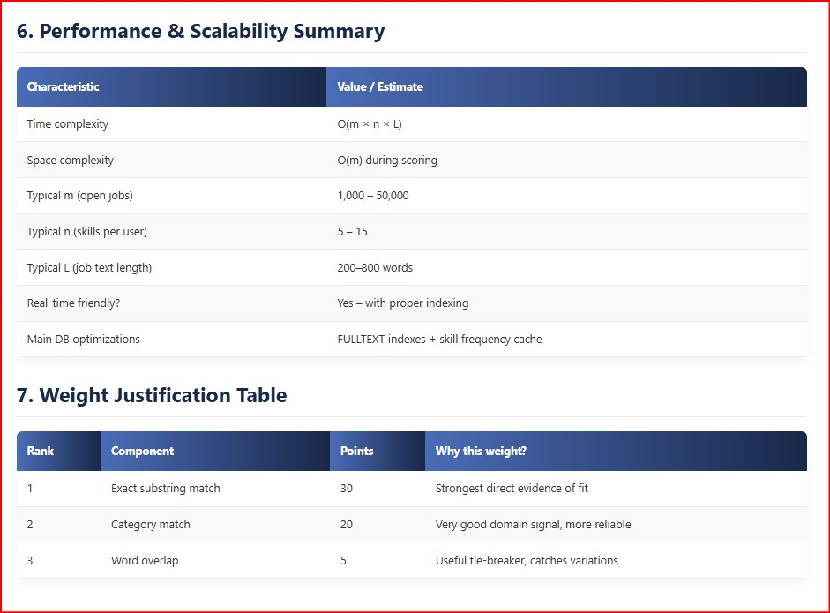
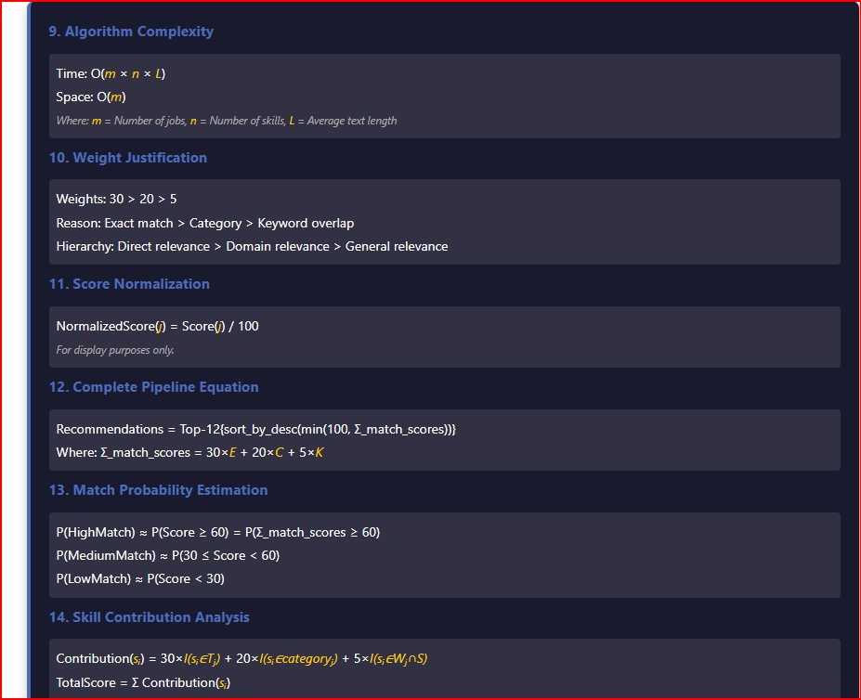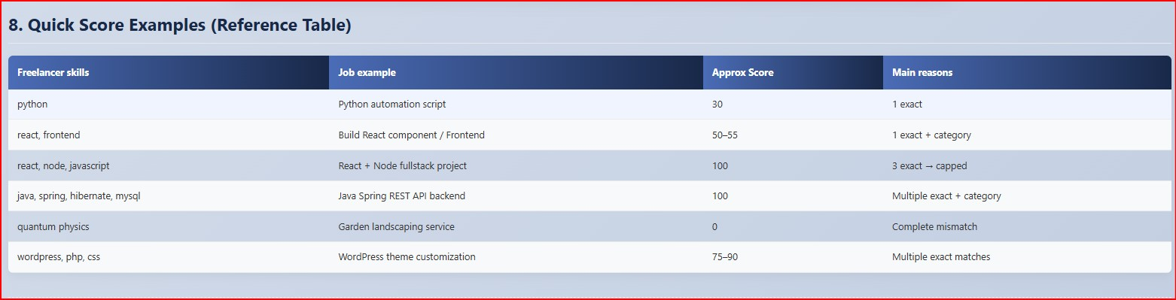

Chapter 5: Conclusion and Future Recommendations

5.1 Conclusion
The implementation of the Kamp job recommendation system provides an effective solution for connecting freelancers with relevant jobs based on their skills, categories, and keywords. By using a hybrid recommendation approach combining exact skill matching, category matching, and keyword overlap the system efficiently suggests the most suitable job opportunities for freelancers.
The system ensures a user-friendly experience, allowing freelancers to receive job recommendations even if they have entered few or incomplete skills. High, medium, and low match levels are clearly displayed, enabling freelancers to quickly identify which jobs best align with their expertise.
Testing confirms that all modules registration, login, and job recommendation algorithm function correctly. Error handling works as expected, and the recommendation algorithm reliably returns a non-empty list of 6–12 jobs, sorted by relevance. Overall, the system provides accurate and fast recommendations, increasing the likelihood of freelancers finding suitable work efficiently.

5.2 Lesson Learned and Outcome
During the development of the freelance website project, several important lessons were learned that contributed to both technical knowledge and personal growth. One of the key lessons learned was the importance of proper planning before starting the development process. Creating clear objectives, identifying user requirements, and designing the system structure helped in reducing confusion during later stages of development. It also highlighted the value of time management, as completing each phase of the project within the scheduled time ensured smooth progress and reduced last-minute pressure.
Another important lesson gained from this project was the practical understanding of web development technologies and system design. Through the process of building the freelance platform, knowledge was gained about designing user-friendly interfaces, managing databases, and handling user authentication features. The project also improved problem-solving skills, as various technical challenges were encountered during development, such as fixing errors, improving system performance, and ensuring proper data flow between different modules. Working on this project helped in understanding how theoretical concepts learned in academic courses can be applied in real-world situations.
Communication and research skills were also strengthened during the project development process. Collecting information about freelancing systems, understanding the needs of freelancers and clients in Nepal, and analyzing similar platforms helped in designing a more practical and useful system. This process also increased awareness of the challenges faced by freelancers, such as finding reliable clients and managing payments, which influenced the features included in the system. Additionally, the importance of testing and user feedback was realized, as testing helped identify system errors and improve the overall quality of the website.
The outcome of this project is the successful development of a functional freelance website designed to connect freelancers and clients in a simple and efficient way. The system provides essential features such as user registration, profile creation, job posting, project bidding, and communication between users. The developed platform demonstrates how technology can be used to support freelancing activities and create employment opportunities, especially in the Nepalese context where freelancing is becoming increasingly popular.

5.3 Future Recommendations
While the current system effectively recommends jobs based on skills and categories, there are several areas for improvement in the future:
- Enhanced Matching Algorithms:
  - Incorporate additional parameters such as freelancer experience, previous job ratings, and location preferences to improve recommendation accuracy.
- Advanced Search & Filters:
  - Provide more granular filters, allowing users to sort jobs by budget, duration, category, or urgency.
- Notification System:
  - Implement email or in-app notifications for new job postings matching a freelancer’s skills.
- Job History & Analytics:
  - Maintain a record of applied and completed jobs and provide analytics to help freelancers track performance and skill gaps.
- Dynamic Skill Learning:
  - Integrate suggested skill improvement based on jobs applied to or frequently appearing in recommendations, helping users upskill over time.
By optimizing these features, the Kamp system can become more intelligent, responsive, and valuable for freelancers, improving the overall efficiency of the platform.

REFERANCE
- Christoph Lutz, Jason Whalley & Volker Stocker, Freelancing in the Digital Age: Understanding Fiverr within the Gig Economy, AoIR Selected Papers (2025).
https://spir.aoir.org/ojs/index.php/spir/article/view/13994?
- Floor Fiers, Resilience in the Gig Economy: Digital Skills in Online Freelancing, Journal of Computer-Mediated Communication (2024).
https://academic.oup.com/jcmc/article-abstract/29/5/zmae014/7742269?
- Sagar Bishwakarma, Niranjan Devkota & Smeeth Bista, Exploring the Rise of the Gig Economy in Nepal, Journal of Business & Management (2024).
https://www.nepjol.info/index.php/jbm/article/view/76177?
- Zubair Nawaz et al., Gig Workers as Sustainable Human Resource: Freelancer Value & Platform Usage Intentions (2024).
https://www.researchgate.net/publication/384022384_Gig_workers_as_sustainable_human_resource_A_study_of_freelancer_value_proposition_and_its_impact_on_platform_usage_intentions?
- Juan Alvarez De La Vega et al., Design Opportunities for Freelancing Platforms, CHIWORK Conference Proceedings (2022).
https://researchportal.northumbria.ac.uk/en/publications/design-opportunities-for-freelancing-platforms-online-freelancers?
- Juan Alvarez De La Vega, Making the Gig Economy Work for Workers (PhD research), Northumbria University (2025).
https://researchportal.northumbria.ac.uk/en/publications/making-the-gig-economy-work-for-workers-an-exploration-of-freelan/?
- Makhmanazarov et al., The Rise of Gig Economies: How Freelancing is Reshaping Labor Markets, Asian Journal of Economics, Business and Accounting (2025).
https://journalajeba.com/index.php/AJEBA/article/view/1819?
- Vivek Kumar Soni et al., Freelancing Platforms: Revolutionizing the Gig Economy, Atlantis Press (2025).
https://www.atlantis-press.com/proceedings/icaaai-25/126012642?
- Zachary Fulker & Christoph Riedl, Cooperation in the Gig Economy: Insights from Upwork Freelancers, arXiv (2023).
https://arxiv.org/abs/2301.08808?
- Juliet Schor, After the Gig: How the Sharing Economy Got Hijacked and How to Win It Back, University of California Press (2020).
https://en.wikipedia.org/wiki/After_the_Gig?
- “Nepal’s Growing Digital Freelancers,” OnlineKhabar (2024).
https://english.onlinekhabar.com/nepals-growing-digital-freelancers.html
- Reddit discussion on Nepali freelancers’ challenges (2025).
https://www.reddit.com/r/technepal/comments/1l8jq9p?

CITED PAPER DETAILS
1 . Christoph Lutz, Jason Whalley & Volker Stocker, Freelancing in the Digital Age: Understanding Fiverr within the Gig Economy, AoIR Selected Papers (2025).
https://spir.aoir.org/ojs/index.php/spir/article/view/13994?

Freelancing in the Digital Age: Understanding Fiverr within the Gig Economy
Authors:
- Christoph Lutz (BI Norwegian Business School, Oslo, Norway)
- Jason Whalley (Northumbria University, UK — noted in some citations and presentations)
- Volker Stocker (Weizenbaum Institute, Germany — noted in affiliations from related sources)
Publication:
- Journal: AoIR Selected Papers of Internet Research (from the Association of Internet Researchers, AoIR)
- Volume/Issue: v2024i0 (AoIR2024 conference proceedings)
- Section: Papers L
- Published: January 2, 2025
- DOI: https://doi.org/10.5210/spir.v2024i0.13994
Keywords: platforms, gig economy, Fiverr, case study, generative AI
Full Abstract:
Platforms play an increasingly prominent role in today’s economy. As big tech companies like Alphabet, Meta and Alibaba leverage their size and access to large amounts of data to provide value for their users and shareholders, platforms have begun to emerge within the gig economy. The gig economy is where individuals rent out their labor, and has rapidly grown in recent years. This paper focuses on Fiverr, an online freelancing platform in the gig economy that allows individuals to sell their services to anyone who can access it. We undertake a longitudinal case study, exploring and analyzing how Fiverr has developed its business to provide a number of services that facilitate the operation of the platform. We explain growth drivers, innovation strategies and show how they favor the buyer, which has created tensions in the operation of the platform. Additionally, we contextualize Fiverr, and online freelancing more generally, within two major socio-technical developments in recent years, namely the Covid-19 pandemic and the rise of generative AI, showing the turbulent times such platforms are currently facing.
Key Themes and Contributions (from abstract and metadata):
- Longitudinal case study of Fiverr's evolution as a gig economy platform.
- Analysis of business development, growth drivers, and innovation strategies.
- Emphasis on how platform features and changes tend to favor buyers (clients) over sellers (freelancers), leading to operational tensions.
- Broader contextualization: Impacts of the COVID-19 pandemic (which boosted remote freelancing) and the emergence of generative AI (which disrupts creative/service-based gigs).
Access:
- The paper is available as a full-text PDF download directly from the publisher's site: https://spir.aoir.org/ojs/index.php/spir/article/view/13994/11896
- It appears to be open access (no paywall mentioned in sources), published under Air’s proceedings model.
- Also mirrored on sites like Research Gate for additional access.
Additional Context:
- This work stems from research presented at the Air 2024 conference (held in Sheffield, UK, October 30 – November 2, 2024), where it was likely presented (e.g., Jason Whaley mentioned presenting related work).
- It builds on platform/gig economy scholarship, highlighting Fiverr's unique position in digital freelancing compared to ride-sharing or task-based apps.

2.Floor Fiers, Resilience in the Gig Economy: Digital Skills in Online Freelancing, Journal of Computer-Mediated Communication (2024).
https://academic.oup.com/jcmc/article-abstract/29/5/zmae014/7742269?

Title: Resilience in the Gig Economy: Digital Skills in Online Freelancing
Author:
- Floor Fiers (Amsterdam School of Communication Research, University of Amsterdam, Amsterdam, The Netherlands)
- Corresponding author email: f.fiers@uva.nl
- ORCID: https://orcid.org/0000-0002-4261-7725
Publication:
- Journal: Journal of Computer-Mediated Communication (JCMC)
- Volume: 29
- Issue: 5
- Article number: zmae014
- Published online: August 26, 2024 (issue date: September 2024)
- DOI: https://doi.org/10.1093/jcmc/zmae014
- Access: Open Access (Creative Commons Attribution License — unrestricted reuse, distribution, and reproduction with proper citation)
- Article history: Received December 10, 2023; Revised July 9, 2024; Accepted July 11, 2024
Full Abstract:
Research on digital inequality suggests that digital skills are integral to participation on gig platforms. Focusing on the case of online freelancing, this article asks what such skills look like and how gig workers translate them into opportunities. Drawing on semi-structured interviews with 21 U.S. online freelancers, I identify moments in which participants approach the gig platform differently because of their digital skills. I find that digital skills enable online freelancers to (1) optimize their use of platform tools, (2) construct alternative pathways when existing tools malfunction, and (3) imagine and blaze new paths that go beyond the platform’s current functionality. These findings suggest that, in the volatile context of gig platforms, digital skills entail not only the ability to leverage platform tools as designed but also the capacity to creatively navigate situations in which the online environment changes, breaks, or proves inadequate for their needs.
Lay Summary (from the paper):
Finding and completing work through online platforms is becoming more popular. Drawing on interviews with so-called online freelancers, this study explores what skills are involved in using these platforms effectively. These digital skills allow people to find appealing work and determine how to apply more efficiently. More digitally skilled individuals are also better prepared to handle unexpected situations that may arise in their work on the platform. Additionally, online freelancers use their skills to devise creative ways to meet their needs when platforms lack the functionality they require. Ultimately, given that the platforms provide little support, digital skills are essential to making a career out of online freelancing.
Key Findings and Contributions:
- Based on qualitative analysis of semi-structured interviews with 21 U.S.-based online freelancers (likely on platforms like Upwork, Fiverr, etc.).
- Digital skills are framed broadly as knowing what's possible digitally and engaging with it effectively/efficiently.
- Three main ways digital skills build resilience in the volatile gig economy:
  - Optimizing platform tools — e.g., advanced use of search filters, keywords, saved searches, client reviews, and metrics to find better gigs, avoid scams, and reduce unpaid application time.
  - Constructing alternative pathways — when tools fail (e.g., glitches, account issues), skilled freelancers workaround via third-party tools (e.g., external file sharing, payment methods) or experimentation.
  - Imagining and blazing new paths — creatively extending beyond platform limits, such as profile tweaks to game algorithms, external monitoring tools, or even borderline tactics (while avoiding bans).
- Platforms offer minimal support, making digital skills crucial for agency, adaptability, and long-term career sustainability in gig work.
- Builds on digital inequality research, shifting from access to advanced, adaptive, creative digital literacies in unstable algorithmic environments.
Access:
- Full article available open access at: https://academic.oup.com/jcmc/article/29/5/zmae014/7742269
- Also mirrored on sites like ResearchGate and author's profile.
- Data: Interview data available upon request from the author.
Additional Context:
- This appears to be derived from the author's dissertation work (noted in related announcements).
- Cited in gig economy and digital skills literature (e.g., Google Scholar shows citations building since publication).
- Author's broader research focuses on gig economy, digital inequality, and platform resistance (University of Amsterdam faculty page: https://www.uva.nl/en/profile/f/i/f.fiers/f.fiers.html).

3.Sagar Bishwakarma, Niranjan Devkota & Smeeth Bista, Exploring the Rise of the Gig Economy in Nepal, Journal of Business & Management (2024).
https://www.nepjol.info/index.php/jbm/article/view/76177?
Title: Exploring the Rise of the Gig Economy in Nepal: Shifting Dynamics and Implications for the Future of Gig Work
Authors:
- Sagar Bishwakarma (MA Graduate, Central Department of Economics, Tribhuvan University, Kritipur, Nepal)
- Niranjan Devkota (Patan Multiple Campus, Tribhuvan University, Lalitpur, Nepal)
- Smeeth Bista (MA Graduate, Central Department of Economics, Tribhuvan University, Kritipur, Nepal)
Publication:
- Journal: Journal of Business and Management (published by School of Business, Pokhara University, Nepal, via NEPJOL — Nepal Journals Online)
- Volume: 8
- Issue: 2
- Pages: 130–149
- Published: December 31, 2024
- DOI: https://doi.org/10.3126/jbm.v8i2.76177
- JEL Classification: J22 (Time Allocation and Labor Supply), J24 (Human Capital; Skills; Occupational Choice; Labor Productivity), O17 (Formal and Informal Sectors; Shadow Economy; Institutional Arrangements)
Full Abstract:
Background: The gig economy is a labor market that facilitates opportunities for both employers and employees to engage in freelance work contracts instead of full-time, permanent work positions.
Objectives: The purpose of this study is to examine the likelihood of workers continuing their participation in Nepal’s emerging gig platforms and to identify the determinants influencing labor supply across various gig sectors. Additionally, the research aims to explore key opportunities, challenges, and support measures necessary to enhance the well-being and sustainability of gig workers in Nepal.
Methods: A binary logit regression model was employed to analyze survey-based primary data collected from 386 gig workers in the Kathmandu Valley. The research encompasses five key sectors: ride-sharing platforms, online tutoring services, e-commerce delivery platforms, food delivery services, and freelance work. To ensure statistical robustness, the study incorporated tests for correlation matrices, goodness of fit, multicollinearity, as well as sensitivity and specificity assessments.
Results: Freelancing has the highest participation rate, but ride-sharing and e-commerce delivery reduce gig work continuation, with ride-sharing dominating. Employed individuals, driven by income, satisfaction, and household head status, are more likely to continue. Full-time work is common in ride-sharing and delivery, while part-time work is more frequent in freelancing and tutoring. Gig workers earn subsistence income, between 30-40k NPR, with income rising with age, education, transport costs, hours worked, and satisfaction.
Conclusion: Nepalese gig workers face substantial challenges. Women are disproportionately under represented. Addressing legal and regulatory challenges, social and health issues, and financial insecurities, Nepal can leverage its gig economy to provide a resilient and inclusive alternative to traditional employment to resolve unemployment across diverse socioeconomic groups.
Keywords: Delivery platforms, gig economy, gig worker, logit regression, ride-sharing
Key Findings and Contributions (from abstract and metadata):
- Empirical study based on primary survey data from 386 gig workers in Kathmandu Valley (Nepal's urban hub).
- Covers major gig sectors in Nepal: ride-sharing (e.g., Pathao, InDrive), food delivery (e.g., Foodmandu, Bhoj), e-commerce delivery, online tutoring, and freelancing (likely including global platforms like Upwork/Fiverr and local ones).
- Highest participation in freelancing; lowest continuation likelihood in ride-sharing and e-commerce delivery (ride-sharing is dominant but challenging).
- Factors increasing continuation: Being employed elsewhere, higher income/satisfaction, household head status.
- Work patterns: Full-time dominant in ride-sharing/delivery; part-time in freelancing/tutoring.
- Income levels: Mostly subsistence (NPR 30,000–40,000/month ≈ USD 225–300), positively correlated with age, education, hours worked, transport costs (e.g., fuel/vehicle for drivers), and job satisfaction.
- Challenges: Underrepresentation of women, legal/regulatory gaps, social/health issues (e.g., no benefits, precarious conditions), financial insecurity.
- Opportunities: Flexible work as an unemployment solution, potential for inclusive growth if supported by policy (e.g., better regulations, social protections).
- Method: Binary logistic regression (dependent: likelihood of continuing gig work), with robustness checks.
Access:
- Full article available as open PDF download from NEPJOL: https://www.nepjol.info/index.php/jbm/article/view/76177/58435 (or direct view: https://www.nepjol.info/index.php/jbm/article/view/76177)
- Also mirrored on ResearchGate (full-text available: https://www.researchgate.net/publication/389495818_Exploring_the_Rise_of_the_Gig_Economy_in_Nepal_Shifting_Dynamics_and_Implications_for_the_Future_of_Gig_Work), Scribd, and Semantic Scholar.
- Appears to be open/restricted access via NEPJOL (copyright held by School of Business; reproduction requires permission, but PDF is freely downloadable).
Additional Context:
- This is one of the early empirical studies on Nepal's gig economy, focusing on local dynamics (e.g., Kathmandu-centric, including ride/food delivery boom post-COVID).
- Author Sagar Bishwakarma has published related opinion pieces (e.g., in Kathmandu Post, 2024) on gig challenges/opportunities in Nepal.
- Cited in subsequent works (e.g., on digital governance in Nepal's gig sector, showing growing academic interest).
- Builds on global gig research but contextualizes to Nepal's developing economy: high youth unemployment, digital growth, but weak labor protections.

Appendix
